Heaven’s light is our guide



RAJSHAHI UNIVERSITY OF ENGINEERING & TECHNOLOGY
Department of Mechatronics Engineering

Lab Report
Experiment No.:01
Experiment Name: Sequential LED Blinking using Atmega32 with Proteus Simulation.

Submitted By: | Submitted To:
Samia Afsana  ID: 2008055  3rd Year , Odd Semester  Department of Mechatronics Engineering  Rajshahi University of Engineering & Technology, Rajshahi-6204. | Md Mehedi Hasan  Assistant Professor  Department of Mechatronics Engineering  Rajshahi University of Engineering & Technology, Rajshahi-6204.
Md. Sakib Hassan Chowdhury
Lecturer
Department of Mechatronics Engineering
Rajshahi University of Engineering & Technology, Rajshahi-6204.

Date of Experiment: 04-03-2024
Date of Submission: 20-04-2024

MTE 3104
Microcontroller and Interfacing Sessional
Experiment No.: 01
Experiment Name: Sequential LED Blinking using Atmega32 with Proteus Simulation.

Objectives:
- To investigate the feasibility and functionality of implementing a sequential LED blinking pattern using the Atmega32 microcontroller within a Proteus simulation environment.
- To assess the performance and reliability of the Atmega32 microcontroller in controlling multiple LEDs sequentially, focusing on factors such as timing accuracy and power consumption.
- To evaluate the effectiveness of Proteus simulation in simulating real-world hardware behavior and validating the designed sequential LED blinking circuit before physical implementation.

Theory:
AVR Study: The Atmega32 is a popular 8-bit microcontroller from the AVR family manufactured by Atmel (now part of Microchip Technology). It features a rich set of peripherals and is widely used in embedded systems.
LED Blinking: In this experiment, the code manipulates the output on PORTC and PORTB to control LEDs connected to each pin. The code iterates through the pins on each port, lighting up a pair of adjacent LEDs at a time. The sequence starts at pin 0 and goes up to pin 7 before reversing the direction.
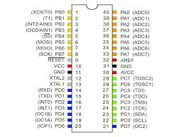
Fig.-1.1: Atmega32 Microcontroller

Working Principle:
- The DDRD is set to 0xFF to configure all pins on PORTD as outputs.
- The code uses a continuous loop to iterate through each pin on PORTD.
- In each iteration, the code lights up a pair of adjacent LEDs by setting the appropriate bit in PORTD.
- A delay of 1 second (_delay_ms(1000)) is added between each transition for clear visualization.

Required Components:
- Atmega32 Microcontroller
- Power
- LED-Blue
- Wire
- Ground

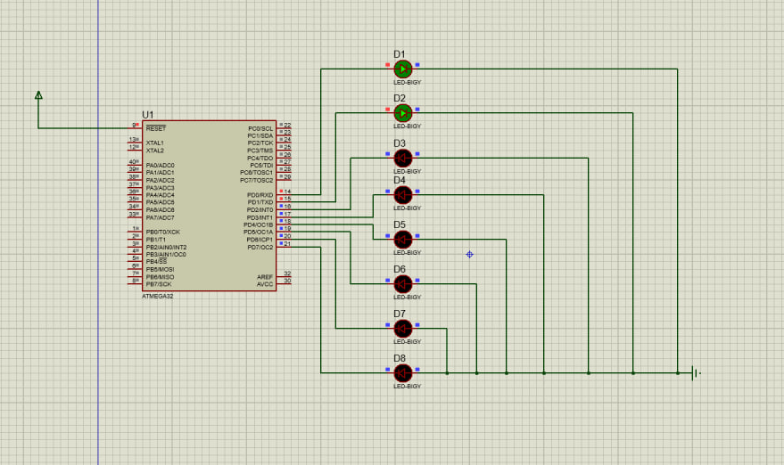
Fig-1.2: LED blinking in Proteus

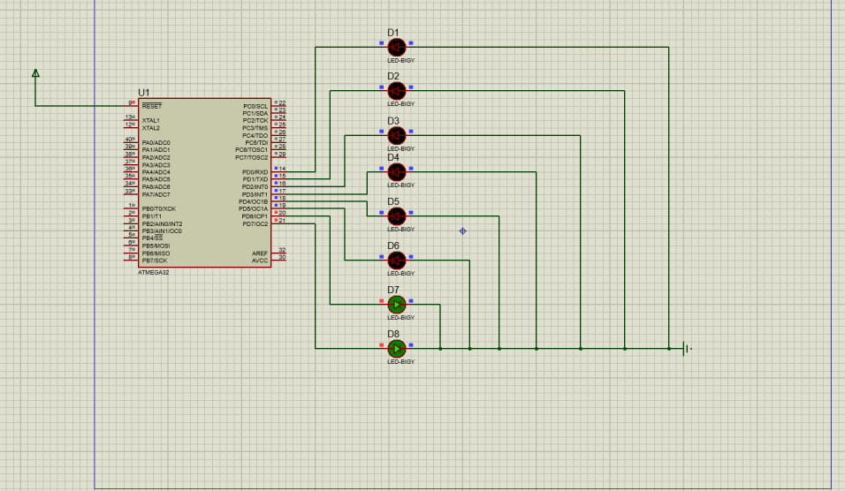
Fig.-1.3: LED blinking in Proteus

Practical Uses:
- Security Systems: Blinking LED lights are often integrated into security cameras, motion sensors, and alarm systems to deter potential intruders. The blinking lights simulate the presence of active surveillance and security measures, enhancing the perceived security of a premises.
- Aviation and Aerospace: Blinking LED lights are used in aviation and aerospace applications for various purposes:
- Aircraft navigation lights: Blinking LED lights on aircraft wings and tails serve as navigation lights, aiding in aircraft visibility and indicating the direction of travel to other aircraft.
- Beacons: Blinking LED beacons are installed on tall structures, such as towers and buildings, to increase visibility for aircraft, especially during low-visibility conditions.
- Vehicle Safety: Blinking LED lights contribute to vehicle safety through various applications:
- Hazard lights: Blinking LED lights serve as hazard lights on vehicles, alerting other drivers to the presence of a stopped or disabled vehicle on the road.
- Turn signals: Blinking LED lights function as turn signals on vehicles, indicating the intention to turn or change lanes, thereby enhancing road safety and communication between drivers.
- Education and Training: Blinking LED lights are used in educational settings and training simulations to illustrate concepts and facilitate learning:
- Electronics education kits: Blinking LED lights are included in electronics kits for educational purposes, allowing students to learn about circuits, programming, and microcontroller functionality through hands-on projects.
- Simulation and modeling: Blinking LED lights are incorporated into simulation and modeling software to visually represent dynamic systems and processes, aiding in understanding complex phenomena.

Conclusion:
Conclusively, the successful execution of the sequential LED blinking project utilizing the Atmega32 microcontroller with Proteus simulation underscores the practical application of embedded systems engineering principles. This hands-on exploration not only illuminates the intricacies of microcontroller programming and circuitry but also underscores the significance of simulation environments in validating and refining electronic designs. Moving forward, this project lays a solid groundwork for advancing LED control systems and inspires further innovation in the realm of microcontroller-driven applications.

Discussion:
The experiment demonstrates how the Atmega32 microcontroller can control external devices such as LEDs using GPIO pins. The code offers the LEDs blinking by sequential control. The experiment visualizes the practical representations of embedded systems.

References:
[1] Johnson, M. (2023, June 15). "Introduction to Atmega32 Microcontroller." Electronics Tutorials.
[2] www.electronicstutorials.com/introduction-to-atmega32-microcontroller/.

